Size Charts

Anvil Women's T-Shirt Size Chart
(in inches) | S | M | L | XL | 2XL
BODY LENGTH | 25 | 26 | 27 | 28 | 29.5
BODY WIDTH | 18 | 20 | 22 | 24 | 26
SLEEVE LENGTH | 13.75 | 14.5 | 15.5 | 16.5 | 17.5

Gildan Women's Ultra Cotton T-Shirt Size Chart
(in inches) | S | M | L | XL | 2XL | 3XL
BODY LENGTH | 25 | 26 | 27 | 28 | 29 | 30
BODY WIDTH | 18 | 20 | 22 | 24 | 26 | 28
SLEEVE LENGTH | 13.75 | 14.5 | 15.5 | 16.5 | 17.5 | 18.5

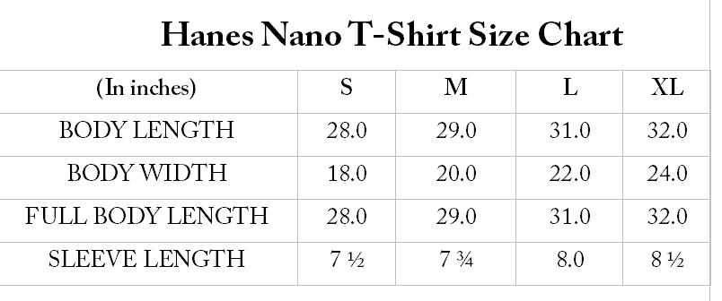
Hanes Long Sleeve Shirt Size Chart
(in inches) | S | M | L | XL
BODY WIDTH | 18.0 | 20.0 | 22.0 | 24.0
FULL BODY LENGTH | 28.0 | 29.0 | 30.0 | 31.0
SLEEVE LENGTH | 33 ½ | 35.0 | 36 ½ | 38.0
WAIST WIDTH | 28.0 | 29.0 | 30.0 | 31.0

LAT ¾ Sleeve Women's V-Neck Size Chart
(in inches) | S | M | L | XL
LENGTH | 23.5 | 24.5 | 25.5 | 26.5
WIDTH | 18.75 | 19.75 | 21.5 | 23.75
SLEEVE | 16 | 16.5 | 17 | 17.5

Anvil 4.5 oz Shirts Size Chart
(in inches) | S | M | L | XL | 2XL
BODY LENGTH | 28.0 | 29.0 | 30.0 | 31.0 | 32.0
BODY WIDTH | 18.0 | 20.0 | 22.0 | 24.0 | 26.0
SLEEVE LENGTH | 8.0 | 8 ½ | 9.0 | 9 ½ | 10.0

Gildan Ultra Cotton T-Shirt Size Chart
(in inches) | S | M | L | XL | 2XL
LENGTH | 29 | 30 | 32 | 33.5 | 34
CHEST | 36 | 40 | 44 | 48 | 52

Gildan Youth T-Shirt Size Chart
(in inches) | XS | S | M | L | XL
LENGTH | 19.75 | 22 | 23 | 23 | 26
CHEST | 33 | 34 | 37 | 39 | 40.5

Fruit of the Loom Women's HD Cotton Shirt Size Chart
(in inches) | S | M | L | XL | 2XL | 3XL
WIDTH | 18.0 | 19.0 | 20 ½ | 22.0 | 23 ½ | 25.0
LENGTH | 25.0 | 26.0 | 27.0 | 28.0 | 29.0 | 30.0

Fruit of the Loom Unisex T-Shirt Size Chart
(in inches) | S | M | L | XL | 2XL
BODY LENGTH | 27.5 | 28.5 | 29.5 | 30.5 | 31.5
BODY WIDTH | 18.0 | 20.0 | 22.0 | 24.0 | 26.0
SLEEVE LENGTH | 8.0 | 8 | 8.25 | 8.5 | 8.75

LAT Youth Long-Sleeve Shirt Size Chart
(in inches) | XS | S | M | L | XL
BODY LENGTH | 19 | 21.5 | 23 | 25 | 26.5
BODY WIDTH | 14 | 16 | 18 | 19 | 20
SLEEVE LENGTH | 15 | 18 | 19.5 | 21.75 | 24

Gildan Heavy Cotton Polo Shirt Size Chart
(in inches) | S | M | L | XL | 2XL
BODY WIDTH | 19.0 | 21.0 | 23.0 | 25.0 | 27.0
BODY LENGTH | 28.0 | 29 ½ | 30 ½ | 31 ½ | 32 ½
SLEEVE LENGTH | 17 ¾ | 19 ¼ | 20 ¾ | 22 ¼ | 23 ¾
(Sleeve length recorded from center of collar)

Anvil Youth T-Shirts Size Chart
(in inches) | XS | S | M | L | XL
BODY LENGTH | 20 ½ | 22.0 | 23 ½ | 25.0 | 26 ½
BODY WIDTH | 16.0 | 17.0 | 18.0 | 19.0 | 20.0
SLEEVE LENGTH | 5.4 | 6.0 | 6 ½ | 7.0 | 7 ½

Hanes Nano-T Shirt Size Chart
(in inches) | S | M | L | XL
BODY LENGTH | 28 | 29 | 31 | 32
BODY WIDTH | 18 | 20 | 22 | 24
SLEEVE LENGTH | 7.5 | 7.75 | 8 | 8.5

Gildan Ultra Cotton Long-Sleeve Shirts Size Chart
(in inches) | S | M | L | XL | 2XL
BODY LENGTH | 28 | 29 | 30 | 31 | 32
BODY WIDTH | 18 | 20 | 22 | 24 | 26
SLEEVE LENGTH | 33.5 | 35 | 36.5 | 38 | 39.5

Dharma Adult Long Leggings Size Chart
(in inches) | XS | S | M | L | XL | 2XL
LENGTH | 36 | 36 | 38 | 38 | 39 | 39
INSEAM | 28 | 28 | 29 | 29 | 30 | 30
WAIST (relaxed/stretched) | 24/34 | 26/36 | 28/38 | 30/40 | 31/41 | 34/44
LEG CUFF (circumference) | 8 | 8 | 9 | 9 | 9 | 10

Dharma “Chakra Pants” Size Chart
(in inches) | XS | S | M | L | XL | 2XL
WAIST (unstretched) | 26 | 27 | 30 | 32 | 34 | 38
INSEAM | 31 | 31 | 32 | 33 | 33 | 33
WAISTBAND HEIGHT | 5 | 5 | 5 | 5 | 5 | 5

LAT Women's V-Neck T-Shirt Size Chart
(in inches) | S | M | L | XL
LENGTH | 25 | 26 | 27 | 29
BUST | 34 | 36 | 40 | 44
SLEEVE | 6 | 6 | 6 | 6

Gildan Softstyle Ringspun T-Shirt Size Chart
(in inches) | S | M | L | XL | 2XL | 3XL
BODY LENGTH | 27 | 28 | 29 | 30 | 31 | 32
BODY WIDTH | 18 | 20 | 22 | 24 | 26 | 28
SLEEVE LENGTH | 15.75 | 17 | 18.25 | 19.5 | 20.75 | 22

Anvil Women's V-Neck Ringspun T-Shirt Size Chart
(in inches) | XS | S | M | L | XL | 2XL
BODY LENGTH | 25 | 25.5 | 26 | 26.75 | 27.5 | 28
BODY WIDTH | 17.5 | 18.5 | 19.5 | 21 | 22.75 | 24.75
SLEEVE LENGTH | 13.75 | 14 | 14.5 | 15 | 15.25 | 16.5

